**Course code: INFS1603**

**Tutorial session (**T18A**):**

**Week number (**Week 8**):**

**Full Name:** Jason Khu

**zID:** 5254974

**Student Solution(s):**

Homework 8A (Due in Week 9)

Add a new row in the ORDERS table with the following data: Order# = 1021, Customer# = 1009, and Order date = July 20, 2009.

**DROP TABLE zjlb_orders_test;**

**CREATE TABLE zjlb_orders_test**

**AS (SELECT \***

**FROM zjlb_orders);**

**INSERT INTO zjlb_orders_test (order#, customer#, orderdate)**

**VALUES (1021, 1009, '20/Jul/2009');**

**SELECT \***

**FROM zjlb_orders_test;**

Modify the zip code on order 1017 to 33222.

**UPDATE zjlb_orders_test**

**SET shipzip = 33222**

**WHERE order# = 1017;**

**SELECT \***

**FROM zjlb_orders_test**

**WHERE order# = 1017;**



Commit

**INSERT INTO zjlb_orders (order#, customer#, orderdate)**

**VALUES (1021, 1009, '20/Jul/2009');**

**UPDATE zjlb_orders**

**SET shipzip = 33222**

**WHERE order# = 1017;**

**COMMIT;**

Add a new row in the ORDERS table with the following data: Order# = 1022, Customer# = 2000, and Order date = August 6, 2009. Describe the error raised and what caused the error.

**INSERT INTO zjlb_orders (order#, customer#, orderdate)**

**VALUES (1022, 2000, '06/Aug/2009');** -- violation

**SELECT constraint_name, constraint_type**

**FROM user_constraints**

**WHERE constraint_name = 'ORDERS_CUSTOMER#_FK';** -- see constraint description

**SELECT \***

**FROM zjlb_customers**

**WHERE customer# = 2000;** -- no record found

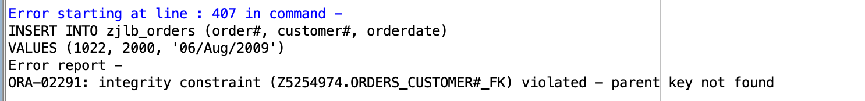

**Error caused since it violates a foreign key constraint – assumption is that the customer# column for the orders table references the customer# column in the customers table**

Delete Order# 1005. You need to address both the master order record and the related detail records.

**DELETE**

**FROM zjlb_orderitems**

**WHERE order# = 1005;** -- since we violated FK constraint in orderitems

**DELETE**

**FROM zjlb_orders**

**WHERE order# = 1005;**

**SELECT \***

**FROM zjlb_orders;**

Homework 8B (Due in Week 9)

Determine how many books are in the Cooking category.

**SELECT \***

**FROM zjlb_books;**

**SELECT COUNT(*)**

**FROM zjlb_books**

**WHERE category = 'COOKING';**

Display the number of books with a retail price of more than $30.00.

**SELECT COUNT(*)**

**FROM zjlb_books**

**WHERE retail > 30;**

Determine the total profit generated by sales to customer 1017. Note: Quantity should be reflected in the total profit calculation.

**SELECT \***

**FROM zjlb_orders o**

**INNER JOIN zjlb_orderitems oi**

**ON o.order# = oi.order#**

**WHERE customer# = 1017;**

**SELECT SUM((paideach*quantity)-shipcost) AS total_profit**

**FROM zjlb_orders o**

**INNER JOIN zjlb_orderitems oi**

**ON o.order# = oi.order#**

**WHERE customer# = 1017;**

Determine the average profit generated by orders in the ORDERS table. Note: The total profit by order must be calculated before finding the average profit.

**SELECT AVG(profit_per_order) as avg_profit_per_order**

**FROM**

**(SELECT SUM(profit_per_entry) AS profit_per_order**

**FROM**

**(SELECT o.order#, ((paideach*quantity)-shipcost) AS profit_per_entry**

**FROM zjlb_orders o**

**INNER JOIN zjlb_orderitems oi**

**ON o.order# = oi.order#)**

**GROUP BY order#);**

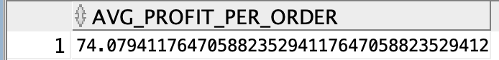

Determine the average retail price of books by publisher name and category. Include only the categories Children and Computer and the groups with an average retail price greater than $50.

**SELECT \***

**FROM zjlb_books;**

**SELECT \***

**FROM**

**(SELECT pubid, category, AVG(retail) as average_r**

**FROM zjlb_books**

**GROUP BY pubid, category)**

**WHERE category IN ('CHILDREN', 'COMPUTER') AND average_r > 50;**

List the customers living in Georgia or Florida who have recently placed an order totalling more than $80.

**SELECT customer#**

**FROM zjlb_orders**

**WHERE order# IN**

**(SELECT order#**

**FROM**

**(SELECT o.order#, SUM(oi.quantity*oi.paideach) AS order_amount**

**FROM zjlb_orders o**

**INNER JOIN zjlb_orderitems oi**

**ON o.order# = oi.order#**

**GROUP BY o.order#)**

**WHERE order_amount > 80)**

**AND shipstate IN ('FL', 'GA')**

**ORDER BY customer#;**

